Gamma - Version
SRS DOCUMENT
(Software Requirements Specification)

REVISION HISTORY
Name | Date | Reason For changes |  | Version
  Reviewer
Tsundzukani Nkuna | 22/April/2025 | - Add Download  - Export to Excell  - Change Outdated Image to New Magotteaux-GMSA Picture | Bheka, Mbhele | Alpha-Version  (4.1.0.1)
Tsundzukani Nkuna | 26/May/2025 | - Update Download  - Update Export to Excell since it was hard coded using JavaScript and could only export only seen Table Information  - Line1, Line2 and Line3 allow Textbox to search by date and Time  - Line1, Line2 and Line3 allow Each Textbox (Grade and Cast Number) to have its own button(Search by Grade and Search by Cast Number)  - Grid view Allow to Display Information From (7 am Today To 7 am Tomorrow) Continuously  - Change Page Index to Number Format (1,2,3…) instead of arrows  - Allow Bath Samples or Pit Samples to be Numbered Using Identity on Charts  - Download Chart Data  - Export Chart Information | Bheka, Mbhele | Beta -Version  (4.2.0.1)

INTRODUCTION
1.1. Purpose
- The purpose of the Chemical Analysis System under the High Chrome Ball Plant is to automate the process of storing, retrieving, analysing, and displaying chemical analysis information. The system is designed to simplify and improve communication between Operators, Technicians, Engineers, and Metallurgists by providing accurate and timely insights into the chemical composition of extracted Molds from the furnace.
- The Chemical Analysis System will enable users to export displayed information as a XLSX file, facilitating accurate record-keeping and enhanced data analysis.
- The Chemical Analysis System enables users to download displayed information as a PDF file, facilitating accurate data comparison.
- By streamlining access to analysed chemical information, the system supports better decision-making, enhances process control, and promotes efficiency in the handling and monitoring of high chrome ball production quality.
1.2. Scope
The Chemical Analysis System is developed to support the High Chrome Ball Plant by automating the workflow related to chemical Information management. The system will:
- Connect to a centralized database/ GM-Reportee to store and retrieve chemical analysis results from Molds extracted from the furnace.
- Offer the ability to track historical information, Charts trends, and performance for quality assurance and process optimization.
- Provide a platform for Metallurgists to review, verify, and provide feedback on the chemical composition of Molds.
- Automatically display information in a user-friendly format, reducing reliance on manual reports or spreadsheet tracking.
- Allow Operators, Technicians, and Engineers to easily access and interpret chemical Information related to production.
- Ensure efficient communication and collaboration between production and quality control teams through real-time information access.
- The system focuses on Line 1, Line 2, Line 3, Bath Plotting Samples and Pit Plotting Samples chemical analysis, but may be scaled or adapted for additional lines or plants in the future.

1.3. Intended Audience and Reading Suggestions
This Software Requirements Specification (SRS) document is intended for a diverse group of stakeholders involved in the development, implementation, and utilization of the Chemical Analysis System within the High Chrome Ball Plant. The primary audiences include:
- Operators: To understand system functionalities related to data input, retrieval, and interpretation pertinent to daily operations.
- Technicians: To gain insights into system interfaces and data handling procedures for maintenance and troubleshooting purposes.
- Engineers: To comprehend system integration points, data flow, and analytical capabilities that support process optimization.
- Metallurgists: To analyse chemical composition data, validate results, and provide feedback for quality assurance.
- Quality Assurance Personnel: To assess system outputs for compliance with quality standards and facilitate audits.
- Project Managers and Stakeholders: To oversee project alignment with organizational goals and ensure resource allocation.

Overall Description
2.1 Product Perspective
- The Chemical Analysis System is a standalone application that already integrate with the existing operational environment of the High Chrome Ball Plant. It is designed to support and enhance the chemical analysis process of extracted Molds from the furnace, particularly those recorded under Line 1, Line 2 and Line 3.
- The system act as a bridge between production-level personnel (Operators, Technicians, Engineers) and quality control experts (Metallurgists), enabling real-time access to chemical composition information and promoting effective communication and decision-making.
- The system uses a user-friendly interface to present analysed results in a structured table format, with features that include:
  - Retrieval and display of recent chemical analysis information.
  - Error handling for empty or missing datasets.
  - Display of the latest readings per sample, including critical elements (e.g., Fe, Cr, C, Mn, etc.).
  - Display Bath Plots and Pit Plots Samples
  - Allow to Download and Export Displayed Information

2.2 Product Features
• Database Connectivity
- Connects to a SQL Server database to retrieve and store chemical analysis information.
Use The Following Credentials
    - Data Source: 10.147.7.84
    - Initial Catalog: Labs
    - Use ID: sa
    - Password: 041608126
- Uses secure connection strings and handles connectivity errors.
• Chemical information Retrieval
- Executes SQL queries to fetch recent chemical analysis results from the Line 1, Line 2 and Line 3 table.
Uses The Following:
    - Connection String
    - Stored Procedures
    - DataTables

- Supports filtering by date and Time range, Grade or cast number (optional future enhancement).
• User-Friendly Data Display
- Presents chemical analysis results in a clear table/grid format on the user interface.
- Displays key attributes such as Date, Time, Cast No, Source, Grade, and elemental composition (e.g., Fe, Cr, Mn, C).
- Display Pit Plotting Samples / Bath Plotting Samples in Chart Format
- Display Textboxes for Searching by Grade or Cast Number and Search Buttons
- Display Download and Export to Excel
• Communication Support
- Facilitates better collaboration between Operators, Technicians, Engineers, and Metallurgists by centralizing access to analysis data.
- Serves as an informal platform for referencing recent chemical trends during decision-making.

2.3 User Characteristics
The system will be used by:
- Operators: Individuals responsible for reviewing and analysing chemical information.
- Technicians/Engineers: Users who will manage the information and ensure the system operates smoothly.
- Metallurgists

2.4 Constraints
- The system will need to connect to a SQL database.
- The database table structure should match the required format for the data.
- The application should be able to handle errors (e.g., when data is missing, or a table doesn't exist).

System Features
3.1 Search by Grade (Textbox and Button)
3.1.1 Description and Priority
Description
- This feature enables users to input a specific grade into a textbox and initiate a search by clicking a corresponding button. The system will then display records matching the entered grade.
Priority:
- High. This functionality is essential for users to efficiently locate, and review records associated with a particular grade.
3.1.2 Stimulus/Response Sequences
- Stimulus: User enters a grade into the textbox and clicks the "Search" button.
Response: The system retrieves and displays all records that match the entered grade.
- Stimulus: User enters a grade that does not exist in the database and clicks "Search".
Response: The system displays a null Table.
- Stimulus: User clicks the "Search" button without entering any grade.
Response: The system doesn’t search or does not return any values.
3.1.3 Functional Requirements
- FR1: The system shall provide a textbox for users to input a grade.
- FR2: The system shall provide a "Search" button adjacent to the grade input textbox.
- FR3: If a grade is entered, the system shall query the database for records matching the entered grade.
- FR4: The system shall display the search results in a structured format, such as a table or list.
- FR5: If no matching records are found, the system shall display a message indicating that no results were found.

3.2 Search by Cast Number (Textbox and Button)
3.2.1 Description and Priority
Description
- This feature enables users to input a specific Cast Number into a textbox and initiate a search by clicking a corresponding button. The system will then display records matching the entered Cast Number.
Priority:
- High. This functionality is essential for users to efficiently locate, and review records associated with a particular Cast Number.
3.2.2 Stimulus/Response Sequences
- Stimulus: User enters a Cast Number into the textbox and clicks the "Search" button.
Response: The system retrieves and displays all records that match the entered Cast Number.
- Stimulus: User enters a Cast Number that does not exist in the database and clicks "Search".
Response: The system displays a null Table.
- Stimulus: User clicks the "Search" button without entering any Cast Number.
Response: The system doesn’t search or does not return any values.
3.2.3 Functional Requirements
- FR1: The system shall provide a textbox for users to input a Cast Number.
- FR2: The system shall provide a "Search" button adjacent to the Cast Number input textbox.
- FR3: If a Cast Number is entered, the system shall query the database for records matching the entered Cast Number.
- FR4: The system shall display the search results in a structured format, such as a table or list.
- FR5: If no matching records are found, the system shall display a message indicating that no results were found.

3.3 Select by Date and Time
3.3.1 Description and Priority
Description
- This feature enables users to select a specific Date and Time into a Select Box and initiate a search. The system will then display records matching the selected Date and Time.
Priority:
- High. This functionality is essential for users to efficiently locate, and review records associated with a particular Date and Time.
3.3.2 Stimulus/Response Sequences
- Stimulus: User Select Date and Time into the Select Box and Execute Search.
Response: The system retrieves and displays all records that match the Selected Date and Time.
- Stimulus: Users select Date and Time that does not exist in the database and clicks "Search".
Response: The system displays a null Table.
3.3.3 Functional Requirements
- FR1: The system shall provide a select box for users to input a Date and Time.
- FR2: If Date and Time is selected, the system shall query the database for records matching the selected Date and Time.
- FR3: The system shall display the search results in a structured format, such as a table or list.
- FR4: If no matching records are found, the system shall display a message indicating that no results were found.

3.4 Download to PDF and Export to Excel
3.4.1 Description and Priority
Description:
This feature allows users to export the displayed data from the Grid View into two formats:
- PDF: Enables users to download the data as a PDF file.
- Excel: Enables users to export the data as an Excel (.xlsx) file.
Upon initiating either action, the system will prompt the user to specify a file name and choose a save location.
Priority:
High. This functionality is crucial for users to efficiently analyse and compare information, as well as maintain accurate records.
3.4.2 Stimulus/Response Sequences
- Stimulus: User clicks the "Download PDF" button.
Response: The system generates a PDF file containing the current Grid View data and prompts the user to save the file.pdf
- Stimulus: User clicks the "Export to Excel" button.
Response: The system generates an Excel (.xlsx) file containing the current Grid View data and prompts the user to save the file.
- Stimulus: User attempts to export when the Grid View is empty (i.e., contains no data).
Response: The system displays a message indicating that there is no data available for export.
3.4.3 Functional Requirements
- FR1: The system shall provide a "Download PDF" button accessible to the user.
- FR2: The system shall provide an "Export to Excel" button accessible to the user.
- FR3: Upon clicking the "Download PDF" button, the system shall generate a PDF file containing the current data displayed in the Grid View.
- FR4: Upon clicking the "Export to Excel" button, the system shall generate an Excel (.xlsx) file containing the current data displayed in the Grid View.
- FR5: The system shall prompt the user to specify a file name and select a save location when exporting to either PDF or Excel.
- FR6: If the Grid View contains no data, the system shall prevent the export action and display a message indicating that there is no data to export.
- FR7: The exported files shall retain the formatting and structure of the Grid View, including headers and data alignment.
Non-Functional Requirements
4.1 Performance Requirements
- The system load data from the database within 15 seconds under normal operating conditions.
- After retrieving data, the system renders and display the data table within 15 seconds.
- The system supports concurrent access by any number of users without significant degradation in response time (i.e., total page load time under 15 seconds).
- For real-time monitoring features (if applicable), updates shall be reflected on the interface with a latency of less than 15 second.
4.2 Safety Requirements
- The system prevents data corruption or loss during unexpected shutdowns through regular automated backups and transaction logging.
- Input validations are implemented to prevent accidental or malicious entry of harmful data.
4.3 Security Requirements
- The system uses secured database credentials.
- Only authorized users will have access to sensitive data.
4.4 Usability Requirements
- The interface should be simple, intuitive, and easy to navigate.
- Users should be able to easily view and understand the data displayed.
5.4 Software Quality Attributes
- Usability: The user interface is simple, intuitive, and easy to navigate. Users should understand how to perform key actions within 5 minutes of first use.
- Availability: The system has a minimum uptime of 99.5%, excluding scheduled maintenance.
- Maintainability: The system architecture should be modular to facilitate updates, with clearly defined interfaces between components.
- Reliability: The system operates continuously without failure for a minimum of 30 days under normal use.
- Scalability: The system supports a scalable architecture capable of handling increasing volumes of data or users with minimal changes.
- Portability: The application is deployable on Windows environment.
- Testability: All modules should be unit tested with at least 80% code coverage and must pass all automated test cases before release.
USE CASES
3.1 Use Cases Figure
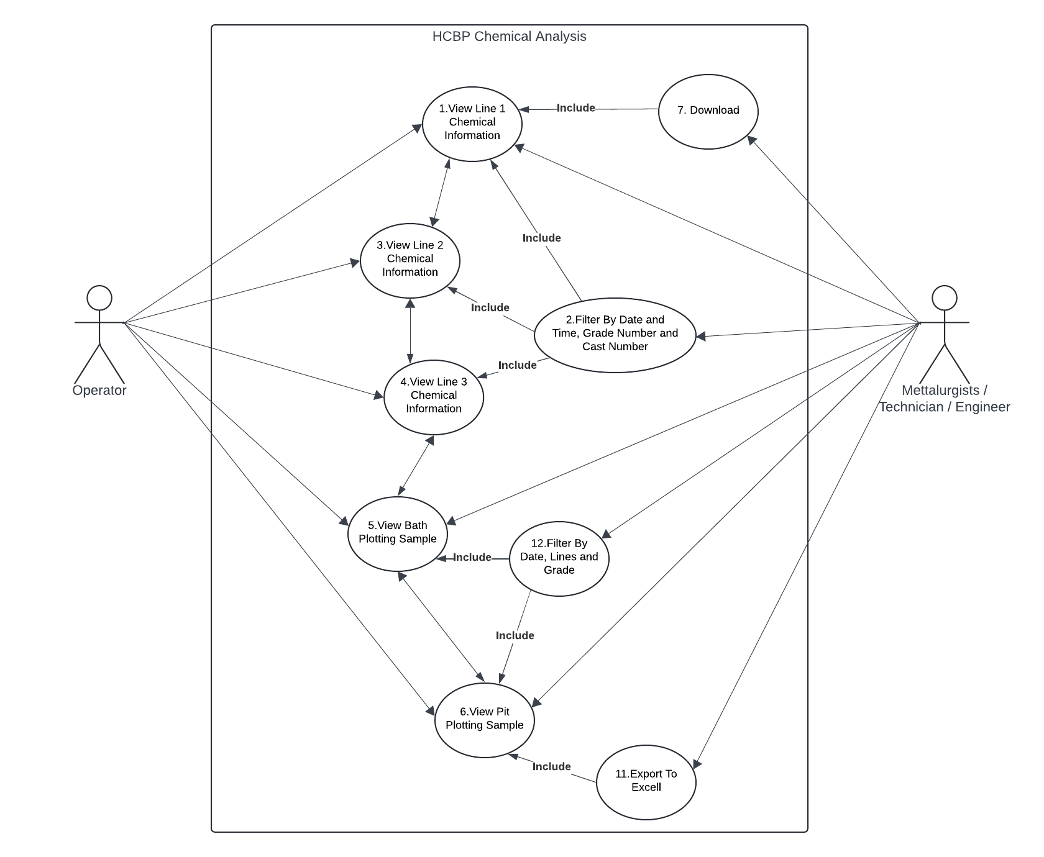

USE CASES SPECIFICATION
4.1 UC-1
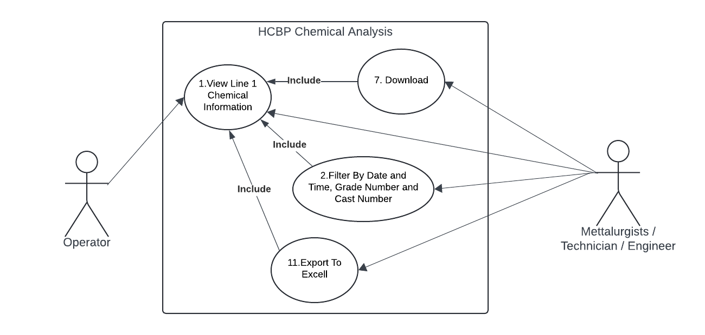
Use Case: short active verb
Use Case ID | UC - 1
Use Case Name | View Line 1 Chemical Analysis
Actor(s) | Operator, Technician, Engineer, Metallurgist
Description | - The system retrieves and displays recent chemical analysis data from the Line1 table in a tabular format for user review.  - In Review of Line 1 Information Filter by Date and Time, Grade Number, Cast Number, download to pdf and Export to Excel are Included
Precondition | - The system is connected to the SQL database.  - The Line1 Grid View exists.  - The table contains at least one data record.
Post-condition | - Data is successfully displayed to the user in a readable table
Alternate Flow | - If the table is empty, the system displays a message: "No data found."  - If the table does not exist, a fallback message or exception is triggered.
Exceptions
  - Database connection fails.
  - Table not found.
  - Data retrieval times out.
Main flow of events | Step | User action | System response
 | 1. | User navigates to the Line 1 view page | Mouse Pointer point to Line1 link
 | 2. | Use Clicks on Line 1 Link | System executes SQL query to retrieve latest chemical information.
 | 3. |  | information is formatted into a table and displayed on screen.
 | 4. | User Filter by Date and Time / Grade Number / Cast Number | System retrieves Filtered Information
 | 5. | User Export to Excell or Download to pdf | System Export to excel if button clicked or download as pdf
4.2 UC-3
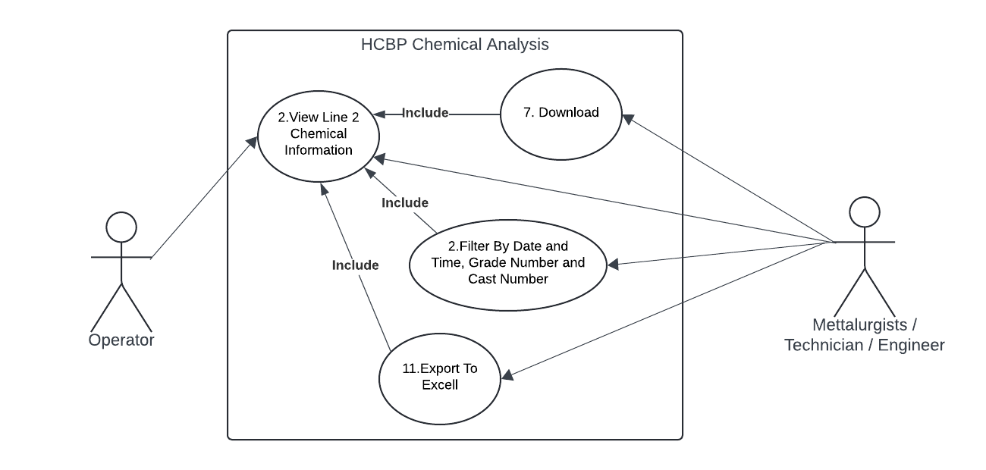
Use Case: short active verb
Use Case ID | UC - 2
Use Case Name | View Line 2 Chemical Analysis
Actor(s) | Operator, Technician, Engineer, Metallurgist
Description | - The system retrieves and displays recent chemical analysis data from the Line2 table in a tabular format for user review.  - In Review of Line 2 Information Filter by Date and Time, Grade Number, Cast Number, download to pdf and Export to Excel are Included
Precondition | - The system is connected to the SQL database.  - The Line2 table exists.  - The table contains at least one data record.
Post-condition | - Data is successfully displayed to the user in a readable table
Alternate Flow | - If the table is empty, the system displays a message: "No data found."  - If the table does not exist, a fallback message or exception is triggered.
Exceptions | - Database connection fails.  - Table not found.  - Data retrieval times out.
Main flow of events | Step | User action | System response
 | 1. | User navigates to the Line 2 view page | Mouse Pointer point to Line2 link
 | 2. | Use Clicks on Line 2 Link | System executes SQL query to retrieve latest chemical information.
 | 3. |  | information is formatted into a table and displayed on screen.
 | 4. | User Filter by Date and Time / Grade Number / Cast Number | System retrieves Filtered Information
 | 5. | User Export to Excell or Download to pdf | System Export to excel if button clicked or download as pdf

4.3 UC-4
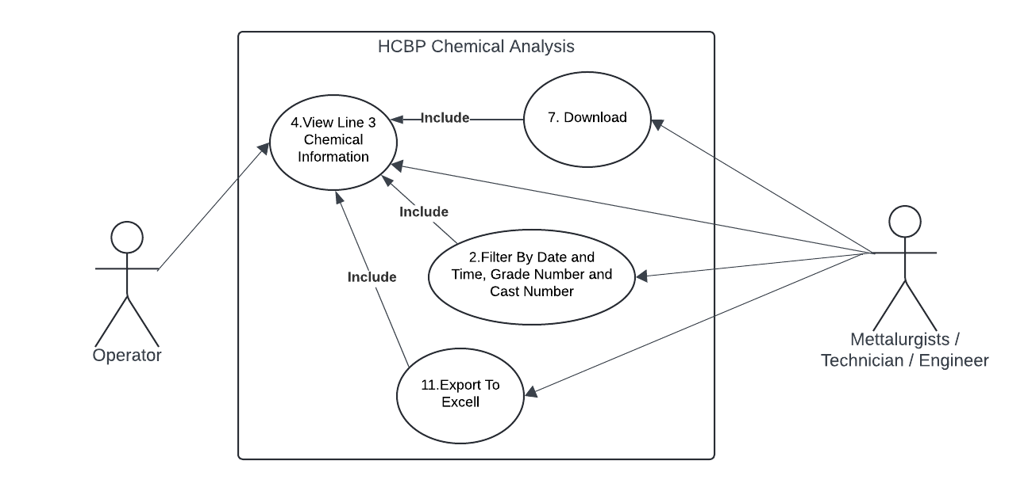
Use Case: short active verb
Use Case ID | UC - 4
Use Case Name | View Line 3 Chemical Analysis
Actor(s) | Operator, Technician, Engineer, Metallurgist
Description | - The system retrieves and displays recent chemical analysis data from the Line3 table in a tabular format for user review.  - In Review of Line3 Information Filter by Date and Time, Grade Number, Cast Number, download to pdf and Export to Excel are Included
Precondition | - The system is connected to the SQL database.  - The Line3 table exists.  - The table contains at least one data record.
Post-condition | - Data is successfully displayed to the user in a readable table
Alternate Flow | - If the table is empty, the system displays a message: "No data found."  - If the table does not exist, a fallback message or exception is triggered.
Exceptions | - Database connection fails.  - Table not found.  - Data retrieval times out.
Main flow of events | Step | User action | System response
 | 1. | User navigates to the Line 3 view page | Mouse Pointer point to Line3 link
 | 2. | Use Clicks on Line 3 Link | System executes SQL query to retrieve latest chemical information.
 | 3. |  | information is formatted into a table and displayed on screen.
 | 4. | User Filter by Date and Time / Grade Number / Cast Number | System retrieves Filtered Information
 | 5. | User Export to Excell or Download to pdf | System Export to excel if button clicked or download as pdf

4.4 UC-5
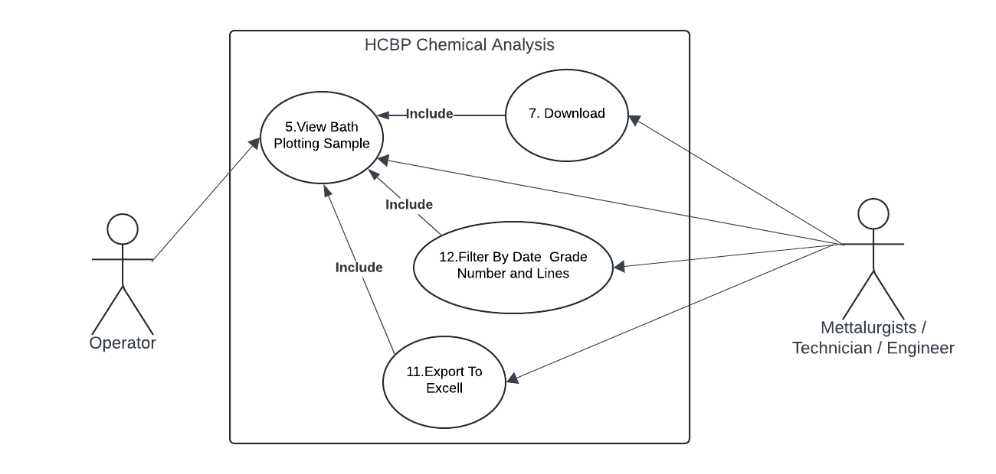
Use Case: short active verb
Use Case ID | UC - 5
Use Case Name | View Bath Plotting Samples
Actor(s) | Operator, Technician, Engineer, Metallurgist
Description | - The system retrieves and displays recent chemical analysis information from the Bath Plotting Samples table in a Chart and tabular format for user review.  - In Review of Bath Plotting Samples Filter by Date, Grade Number, Lines, download to pdf and Export to Excel are Included
Precondition | - The system is connected to the SQL database.  - The Bath Plotting Samples table exists.  - The table contains at least one Information record.
Post-condition | - Information is successfully displayed to the user in a readable Charts
Alternate Flow | - If the table is empty, the system displays a message: "No data found."  - If the table does not exist, a fallback message or exception is triggered.
Exceptions | - Database connection fails.  - Table not found.  - Data retrieval times out.
Main flow of events | Step | User action | System response
 | 1. | User navigates to the Bath Plotting Samples Link | Mouse Pointer point to Bath Plotting Sample link
 | 2. | Use Clicks on Bath Plotting Sample Link | System executes SQL query to retrieve latest chemical information.
 | 3. |  | information is formatted into a Chart and displayed on screen.
 | 4. | User Filter by Date/ Grade Number / Lines | System retrieves Filtered Information
 | 5. | User Export to Excell or Download to pdf | System Export to excel if button clicked or download as pdf

4.5 UC - 6
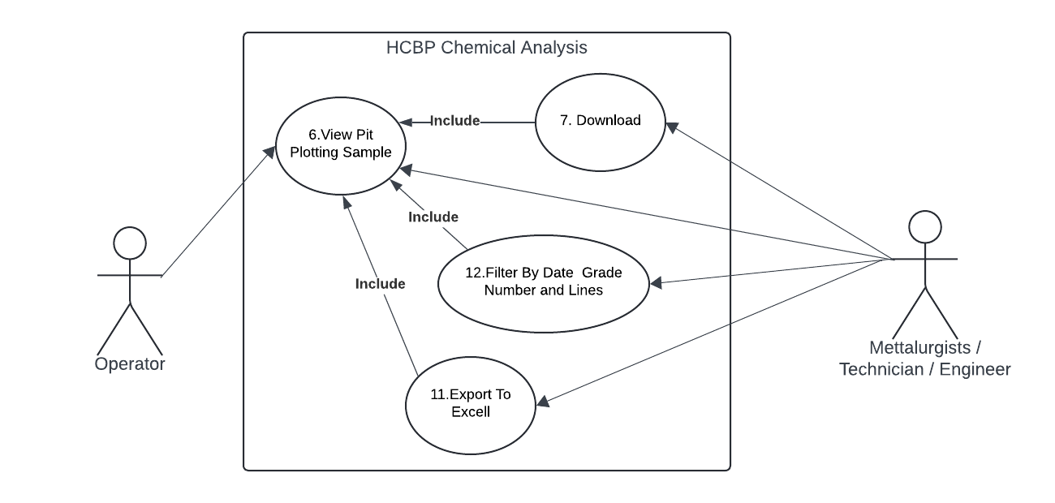
Use Case: short active verb
Use Case ID | UC - 6
Use Case Name | View Pit Plotting Samples
Actor(s) | Operator, Technician, Engineer, Metallurgist
Description | - The system retrieves and displays recent chemical analysis information from the Pit Plotting Samples table in a Chart and tabular format for user review.  - In Review of Pit Plotting Samples Filter by Date, Grade Number, Lines, download to pdf and Export to Excel are Included
Precondition | - The system is connected to the SQL database.  - The Bath Plotting Samples table exists.  - The table contains at least one Information record.
Post-condition | - Information is successfully displayed to the user in a readable Charts
Alternate Flow | - If the table is empty, the system displays a message: "No data found."  - If the table does not exist, a fallback message or exception is triggered.
Exceptions | - Database connection fails.  - Table not found.  - Data retrieval times out.
Main flow of events | Step | User action | System response
 | 1. | User navigates to the Pit Plotting Samples Link | Mouse Pointer point to Pit Plotting Sample link
 | 2. | Use Clicks on Pit Plotting Sample Link | System executes SQL query to retrieve latest chemical information.
 | 3. |  | information is formatted into a Chart and displayed on screen.
 | 4. | User Filter by Date/ Grade Number / Lines | System retrieves Filtered Information
 | 5. | User Export to Excell or Download to pdf | System Export to excel if button clicked or download as pdf

USER ACTIVITY DIAGRAM AND USER BREAKDOWN STORIES

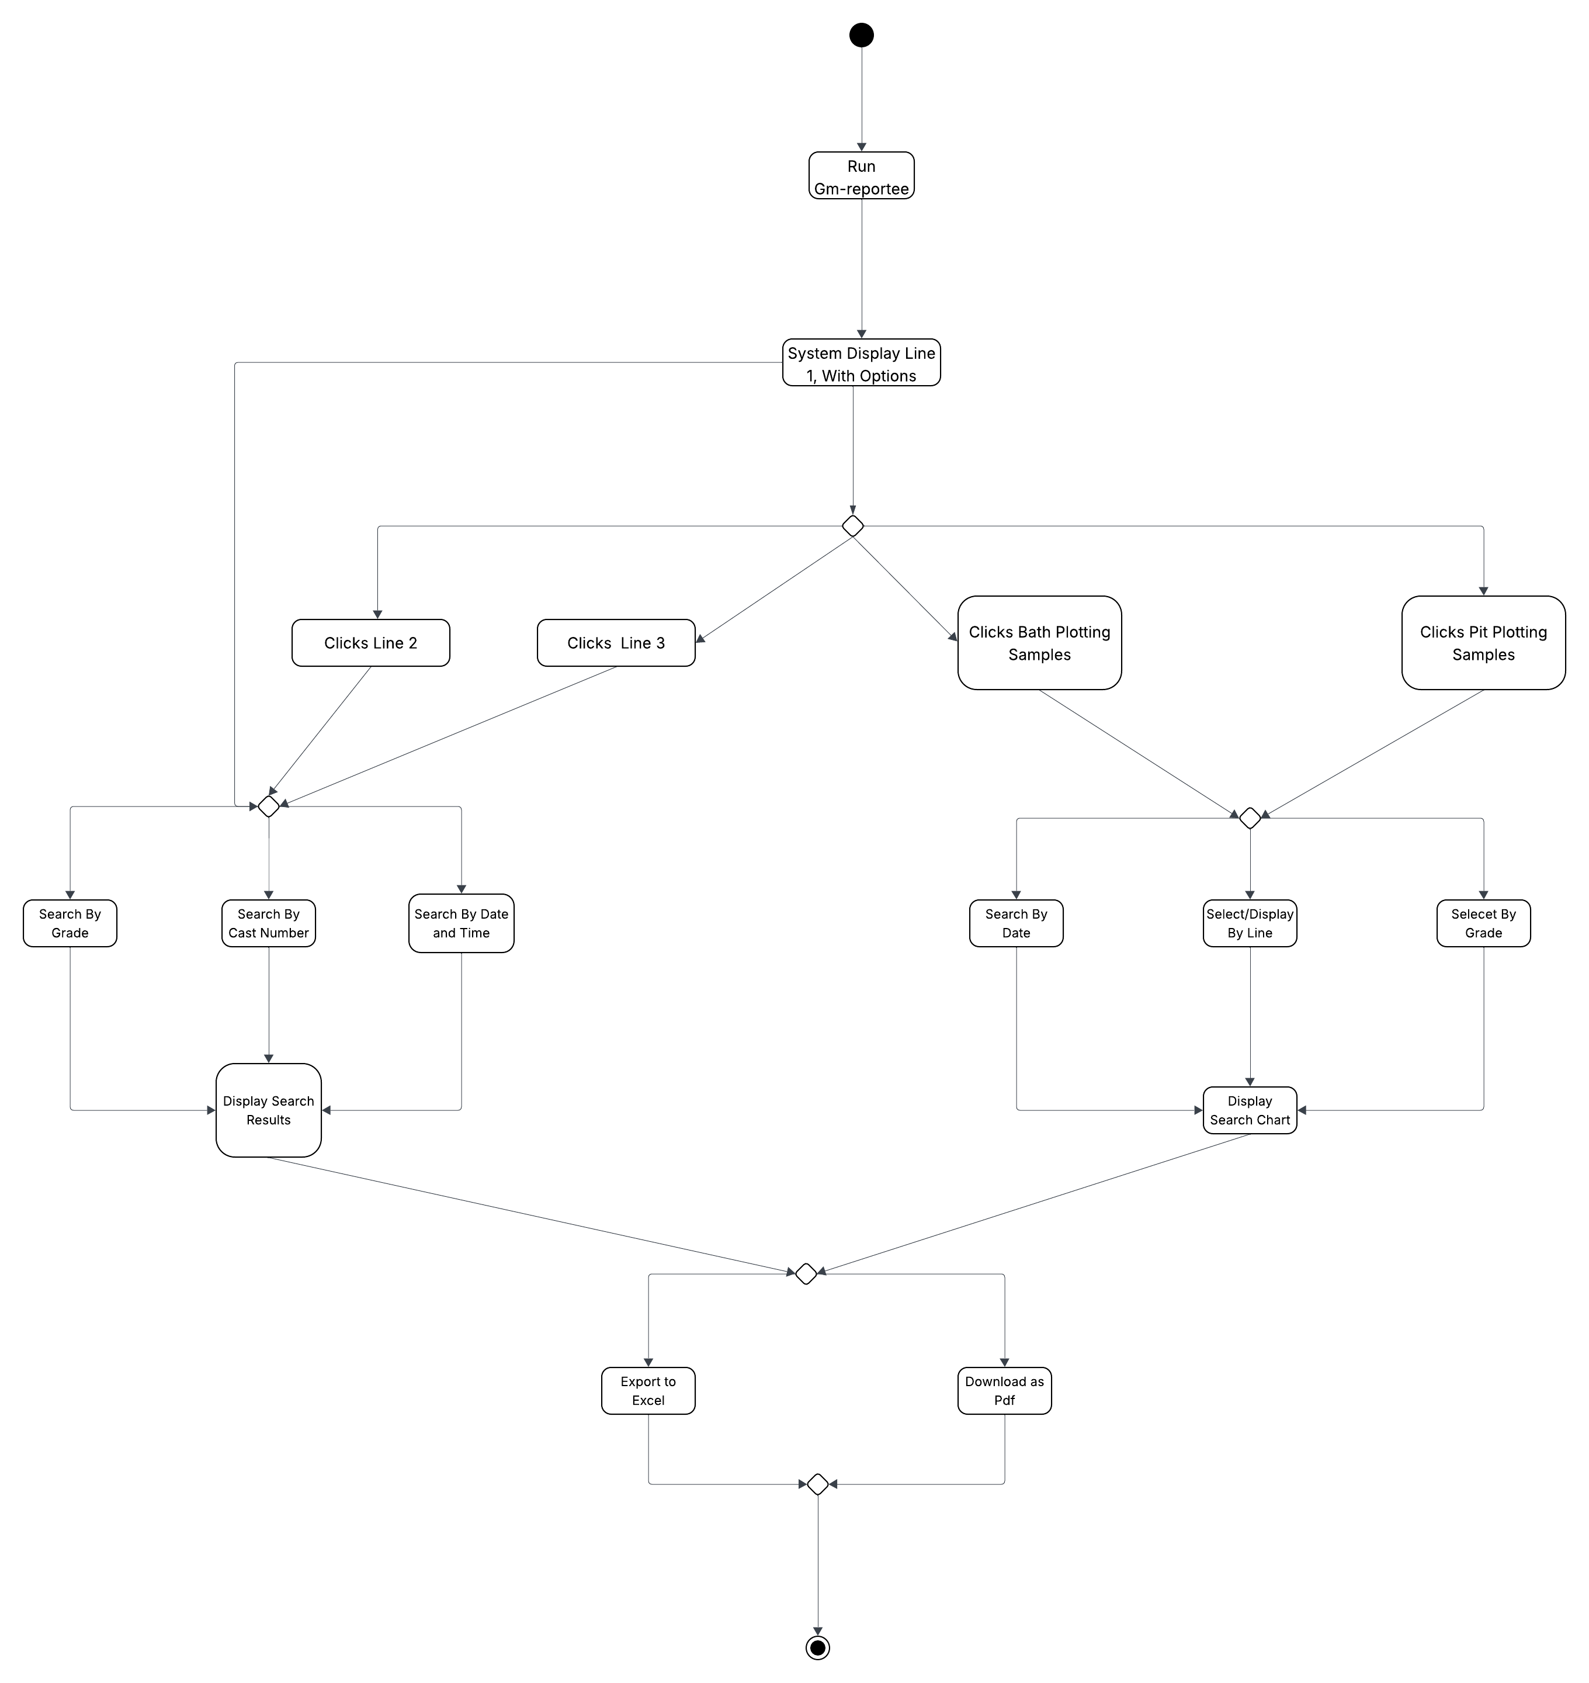

6.1. Operator View Line 1 Information
|
IF (Data! = Null)
1.1 Display Line 1 Current Operator
1.2 Display Line 1 Grades
1.3 Display Line 1 Pit / Bath Samples used for the day
1.4 Filter Line 1 Information
1.4.1 Filter by Date
1.4.2 Filter by Time
1.4.3 Filter by Grade Number
1.4.4 Filter by Cast Number
1.5 Download
1.5.1 Download Page Content
1.5.2 Download Table Data
1.6 Export to Excell
1.6.1 Export Table Data to Excel
|
ELSE
{“Console No Line 1 Information Available for Display”}

6.2. Operator View Line 2 Information
|
IF (Data! = Null)
2.1 Display Line 2 Current Operator
2.2 Display Line 2 Grades
2.3 Display Line 2 Pit / Bath Samples used for the day
2.4 Filter Line 2 Information
2.4.1 Filter by Date
2.4.2 Filter by Time
2.4.3 Filter by Grade Number
2.4.4 Filter by Cast Number
2.5 Download
2.5.1 Download Page Content
2.5.2 Download Table Data
2.6 Export to Excell
2.6.1 Export Table Data to Excel
|
ELSE
{“Console No Line 2 Information Available for Display”}

6.3. Operator View Line 3 Information
|
IF (Data! = Null)
3.1 Display Line 3 Current Operator
3.2 Display Line 3 Grades
3.3 Display Line 3 Pit / Bath Samples used for the day
3.4 Filter Line 2 Information
3.4.1 Filter by Date
3.4.2 Filter by Time
3.4.3 Filter by Grade Number
3.4.4 Filter by Cast Number
3.5 Download
3.5.1 Download Page Content
3.5.2 Download Table Data
3.6 Export to Excell
3.6.1 Export Table Data to Excel
|
ELSE
{“Console No Line 3 Information Available for Display”}

6.4. Operator View Bath Plotting Samples Charts
|
IF (Data! = Null)
4.1 Display Bath Plotting Samples in Chart
1.4.1 Filter by Date
1.4.2 Filter by Line 1, Line 2 and Line 3
1.4.3 Filter by Grade Number
4.2 Download
1.5.1 Download Page Content
1.5.2 Download Bath Plotting Chart
4.3 Export to Excell
|
ELSE
{“Console No Bath Plotting Chart Samples Information Available for Display”}

6.5. Operator View Pit Plotting Samples Charts
|
IF (Data! = Null)
5.1 Display Pit Plotting Samples in Chart
5.4.1 Filter by Date
5.4.2 Filter by Line 1, Line 2 and Line 3
5.4.3 Filter by Grade Number
5.2 Download
5.5.1 Download Page Content
5.5.2 Download Pit Plotting Chart
5.3 Export to Excell
|
ELSE
{“Console No Pit Plotting Chart Samples Information Available for Display”}
DATABASE ERDs
7.1 Erd Figure
